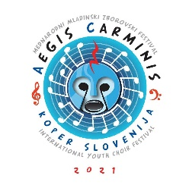

APPLICATION FORM
COMPLETE IN CAPITAL LETTERS

CHOIR
Name of the choir |  |  |  |  | Category
Street, number |  | City, number |  |  | State
E-mail address |  | Telephone number (mobile) |  |  | Fax number (optional)
CONTACT PERSON
Name and surname |  | E-mail address |  |  | Telephone number (mobile)
REPERTOAR FORM
The name of the composer | Composer's surname |  |  |  | Year of birth and death
The title of the composition |  |  | Author of the text
Composed (or published) in year | Publisher |  |  |  | Duration
IF MADE AS VIRTUAL CHOIR
Video concept by | Video editing by |  |  |  | Date of video production
Materials which must be included to the application:
- Short biography (approx. 500- 700 characters)
- A photo (in good resolution)
Send all materials to info@aegiscarminis.si
Thank you in advance.
By signing, we authorize the use of the recording and its playing at the festival concert SLOVENIAN MUSIC FROM NEAR AND FAR.
The choir receives no fee for use of recording.

Place and date: |  |  |  | Signature:

